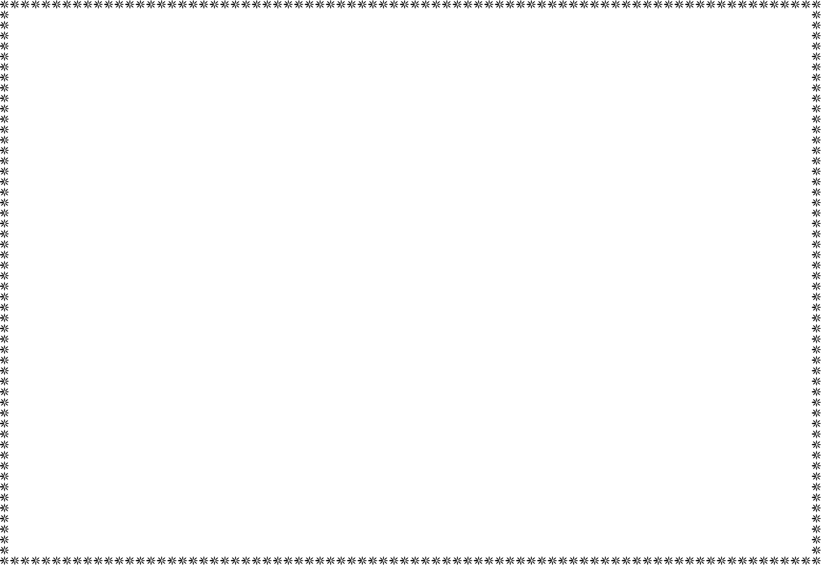{{company_name}}
UEN: {{company_UEN}}
(Incorporated in the Republic of Singapore under the Companies Act 1967)

Registered Office: | {{company_address}} | Certificate No. | {{shareholder_certNo.}}
 |  | No. of Shares | *{{shareholder_numofshares}}*

{{shareholder_name}}
{{shareholder_address}}

This is to certify that

Is the Registered Holder(s) of | **{{shareholder_numofshares_inwords}}**
Ordinary Shares, fully paid in | {{company_name}}
subject to the Constitution of the Company.

Dated this on {{company_reg_date}} Executed as a deed pursuant to Section 41B of the Companies Act

➜ Sign / 签字
____________________________________________
Director ({{Chairman}})

➜ Sign / 签字
____________________________________________
{{title}} ({{director_name}})
NOTE: No transfer of any portion of the shares comprised in this Certificate
will be registered unless accompanied by this Certificate.

